
2024 KCPS Pre-K Sites
Apply online at EnrollKC.org or Apply in person at 2901 Troost Ave. KCMO 64109
For More Information Contact KCPS Pre-K Programs Specialist, Aaliyah Williams (816) 418-6988
Neighborhood Schools
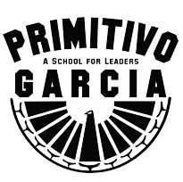  Primitivo Garcia Elementary  1000 W 17th St. KCMO  To Tour Call  (816) 418 - 8725  *Pre-K-6 | 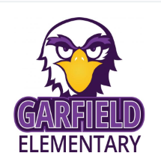  Garfield Elementary  436 Prospect Ave. KCMO  To Tour Call  (816) 418 - 3600  K-6 | 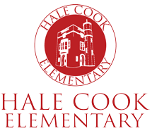  Hale Cook Elementary  7302 Pennsylvania Ave. KCMO  To Tour Call  (816) 418 – 1600  *Pre-K-6
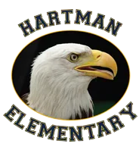  Hartman Elementary  8111 Oak St. KCMO  To Tour Call  (816) 418-1750  *Pre-K-6 |   J.A. Rogers Elementary  6300 E. 23rd St. KCMO  To Tour Call  (816) 418-4770  *Pre-K-6 | 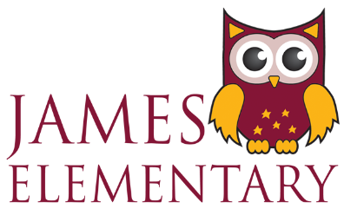  James Elementary  5810 Scarritt Ave. KCMO  To Tour Call  (816) 418-3700  *Pre-K-6
  Pitcher Elementary  9915 E 38th Terr. KCMO  To Tour Call  (816) 418 - 4550  *Pre-K-6 | 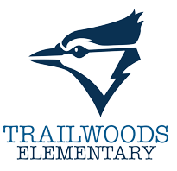  Trailwoods Elementary  6201 E. 17th St. KCMO  To Tour Call  (816) 418 - 3250  *Pre-K-6 | 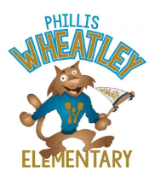  Phillis Wheatley  2415 Agnes Ave. KCMO  To Tour Call  (816) 418 - 4825  K-6
Signature Schools
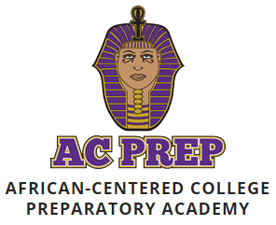  African-Centered Prep  6410 Swope Pkwy. KCMO  To Tour Call  (816) 418-1175  *Pre-K-8 | 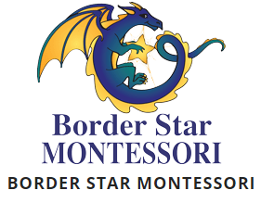  Border Star Montessori  6321 Wornall Rd. KCMO  To Tour Call  (816) 418 - 5150  *Pre-K-6 |   Holliday Montessori  7227 Jackson Ave. KCMO  To Tour Call  (816) 418 - 1950  *Pre-K-6
Cooperative Sites
  Wendell Phillips  2400 Prospect Ave. KCMO  *Pre-K-6 |  | Operation Breakthrough  3039 Troost Ave. KCMO  (816) 756-3511
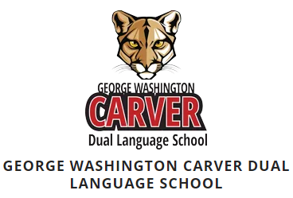  Carver Dual Language  4600 Elmwood Ave.  *PK-6 |  | 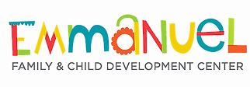  Emmanuel Family & Child Development Center  4736 Prospect Ave. KCMO  (816) 921-3164

